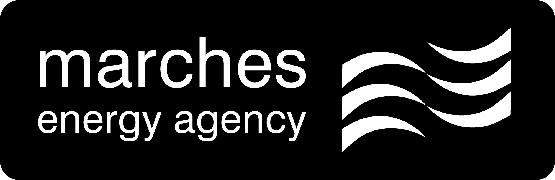
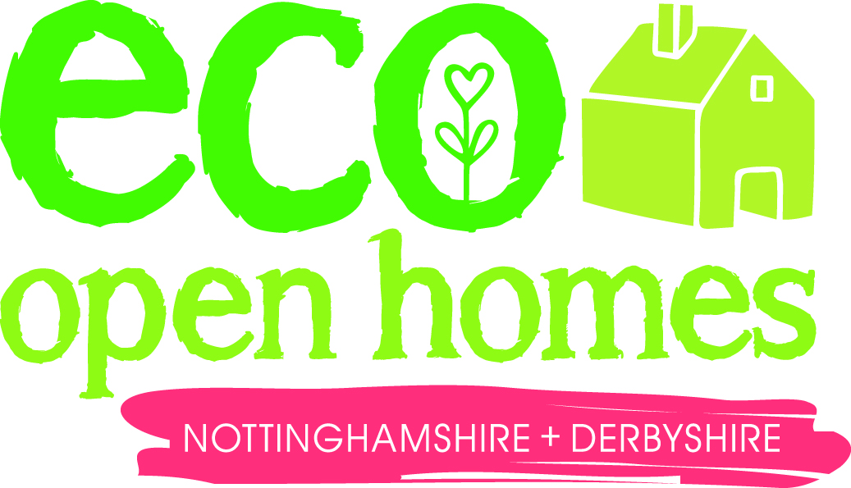
PRESS RELEASE
1st April 2014
Contact: Caroline Harmon: 07748 508704 / caroline.harmon@mea.org.uk
Derbyshire & Nottinghamshire Homes Sought For Eco Home Open Event

For Immediate Release
Photos attached: 'More than 300 people visited homes in 2014’
Householders available for interview and homes available for filming

Derbyshire & Nottinghamshire residents who have reduced their energy bills, insulated their home, put solar panels on the roof or even built their own eco home, are being invited to open their doors to inspire others this spring as part of the third annual Nottinghamshire and Derbyshire Eco Open Homes event.

Marches Energy Agency, a local charity, is looking for householders who have made a variety of energy efficiency and environmental improvements and would like to open their homes for a few hours, or a whole day, during May 2015.

The event is an opportunity to inspire others to make their homes warmer, cheaper to heat and better for the environment by showing them what you’ve done – be it simple draught proofing, a highly efficient boiler, rainwater harvesting, or generating your own renewable energy. There’s no need to be an expert or to have opened you home before as Marches is offering support to those taking part.

Caroline Harmon of Marches Energy Agency, organisers of the event, said:

‘Last year, more 325 people visited homes and buildings around the two counties. We’re lucky to have lots of energy efficient, eco homes in the area and this year we’d like to help even more of them open their doors to the public. We’re offering training and help with publicity to all homes taking part.’

If you would like to take part contact Caroline Harmon on 07748 508704 or caroline.harmon@mea.org.uk.

Details of houses which are open, and when, will be listed on the event’s website: www.everybodys-talking.org/ecohomes

The event is being funded by the Nottinghamshire and Derbyshire Local Authority Energy Partnership and a Green Open Homes Grant from the Centre for Sustainable Energy.

ENDS

Contact: Caroline Harmon: 07748 508704 / caroline.harmon@mea.org.uk

Notes for Editors:
- The Nottinghamshire and Derbyshire Eco Homes Open Week is being organised by Marches Energy Agency (MEA), a Midlands charity and the Nottinghamshire and Derbyshire Local Authorities Energy Partnership (LAEP). It has funding from the Green Open Homes Network: www.greenopenhomes.net
- Marches Energy Agency (MEA) is a registered charity and not-for-profit social enterprise working across the Midlands. We specialise in the delivery of practical, effective and creative ways of promoting energy reduction and renewable energy solutions. We have won awards for our work including the prestigious Ashden Award and the West Midlands Social Enterprise Mark. Our mission is to address fuel poverty, to enhance local energy security and resilience, and to help create low carbon citizens, communities, organisations and economies.www.mea.org.uk
- The Local Authorities Energy Partnership (LAEP) is made up of 18 local authorities in Derbyshire and Nottinghamshire. It supports and co-ordinates activities to tackle fuel poverty and climate change and to develop sustainable energy solutions across the two counties. This includes high profile public campaigns which encourage individuals and communities to reduce carbon emissions and save money. www.everybodys-talking.org
- www.everybodys-talking.org is the climate change portal for Nottinghamshire and Derbyshire. It includes a wealth of information about tackling climate change and fuel poverty locally as well as resources to support local community groups. It is funded by the LAEP and run by MEA.
- The Community Climate Action Network (CCAN) offers free services, including a monthly e-bulletin, to more than 300 people, representing more than 85 community groups and more than 100 third sector organisations, living in Derbyshire and Nottinghamshire who are working to tackle climate change. www.everybodys-talking.org/communities-area/community-support

