My name is __________________________ and I live at ____________________.
I’m taking part in the Nottinghamshire and Derbyshire Eco Homes Open event during May 2015. I’ll be opening my home to the public to show visitors the things I’ve done to make it cheaper and easier to heat, warmer to live in, and better for the environment. You’d be very welcome to visit at these times:

To find out about others homes which are opening, visit the event’s website:
www.everybodys-talking.org/ecohomes
You can just turn up to my event / You need to pre-book a place at my event (delete as appropriate)
To pre-book contact:

My name is __________________________ and I live at ____________________.
I’m taking part in the Nottinghamshire and Derbyshire Eco Homes Open event during May 2015. I’ll be opening my home to the public to show visitors the things I’ve done to make it cheaper and easier to heat, warmer to live in, and better for the environment. You’d be very welcome to visit at these times:

To find out about others homes which are opening, visit the event’s websites:
www.everybodys-talking.org/ecohomes
You can just turn up to my event / You need to pre-book a place at my event (delete as appropriate)
To pre-book contact:
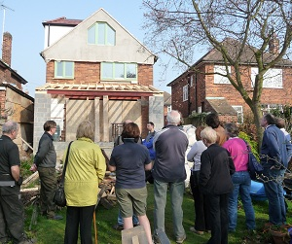
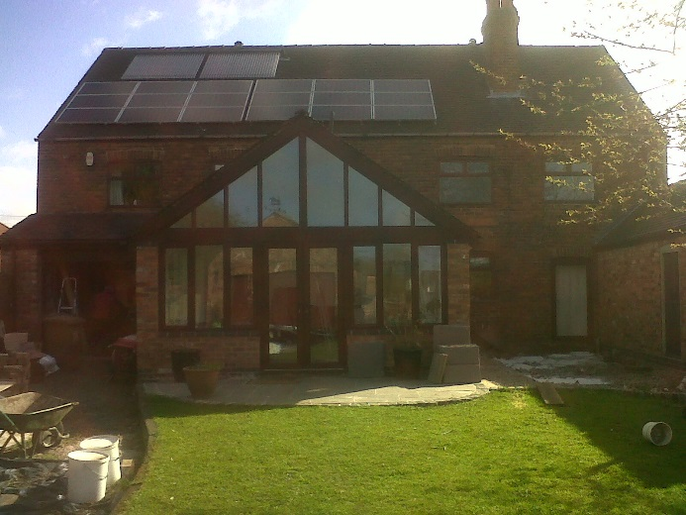
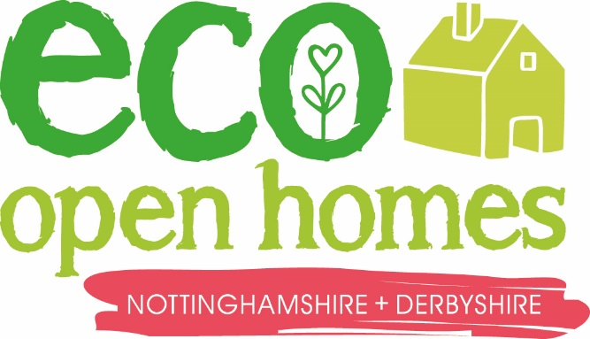
May 2015

Real Homes, Real People

A home near you is opening!
May 2015

Real Homes, Real People

A home near you is opening!

