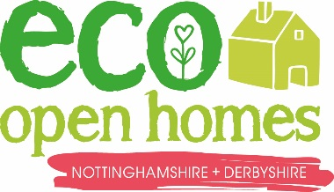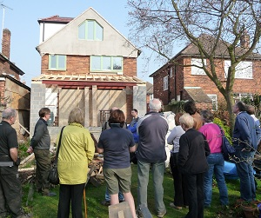

May 2015

Real Homes, Real People

[www.everybodys-talking.org/ecohomes](http://www.everybodys-talking.org/ecohomes)

Your local open house is:

27 Warmer Road, Sunnydale

Open 9th May only, 10am – 5pm

